- Blöndu Area

Industrial and commercial sites
Let us surprise you
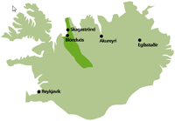
Iceland may not currently be high on your list of locations for an new industrial, commercial or technological installation. But wait - a number of global organisations have already discovered some of the significant advantages that we can offer.
North-West Iceland is in a unique position to be able to provide attractive opportunities for industrial and commercial developers:
- Greenfield sites
- Plentiful supplies of cheap electricity
- Good supplies of clean water
- Modern infrastructure
- A secure environment
- Clean air
The County of Austur Húnavatnssýsla is a region preparing for extensive development. Rich natural and human resources make this an ideal location for your next project.
- Why choose us?
A number of global enterprises have already discovered the benefits of basing new installations in Iceland. The heavy industry and hi-technology sectors have found productive, cost-efficient sites in seemingly remote regions with sparse populations. Medium-sized and small companies enjoy similar advantages.
What can the County of Austur Húnavatnssýsla offer you?
We are ready to discuss new projects of all sizes. We believe that we can match the physical resources of other areas of the country in which international companies have chosen to build new production units.
- Large or small sites for industrial or commercial developments
- Low land prices
- Plentiful supply of cheap electricity
- Clean electricity generated using renewable resources
- Reliable, high-capacity, high-speed data connections
- Clean, high-grade water supplies
- Hot water supplies
- Stable, well-educated workforce
- Low geological threat
- Low security threat
- Family-oriented environment
- High level of services
Vast potential
Iceland is a relatively small country. It does not have a large population, but it does have a vast, untapped reserve of renewable energy resources. As a people, Icelanders have developed flexibility and good communication skills. Contact one of our international representatives for more information about what we can offer you. A brief informal chat could lead to a highly advantageous contract.

Who are we?
We understand that many of our official titles may present you with some difficulties - they are rather long in Icelandic (and often even longer in English). We are:
Samtök sveitarfélaga á Norðurlandi vestra - SSNV or The Region Association in North-West Iceland.
Our Economic Development Unit handles industrial and commercial matters for the counties in the region. We provide consultation services in promoting employment and commerce to participating authorities and companies.
Ready to listen
The County of Austur Húnavatnssýsla is particularly well positioned to provide opportunities for new and developing industrial and commercial concerns. Rich natural and human resources make it an ideal location for your next project. Our international representatives can provide information about what we can offer you. Check our Contact us page to find out how to get in touch.

Locations
The County of Austur Húnavatnssýsla is a region that includes two main population centres. The remaining area is administered as a single rural district.
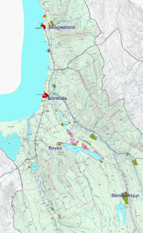

Blönduós
Status: Town
Population: 1000
Main fields of employment: Agricultural and food products. Light industry.
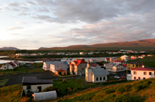
Blönduós is the main service centre for the surrounding district. It is the base for local government and the district health authority.
Although the population is relatively low, the town is a rural hub and provides a full range of community services, including:
- Modern health centre
- Schools
- Police
- Emergency services
- Sports and recreation facilities
- Vehicle sales and repairs
- Maintenance services
- Utilities providers
- Range of retail outlets
- Hotel and restaurant
- Cultural services
Food production is the major employment sector in the town along with other light industries.
Tourism has become increasingly important in recent years.
The national highway passes through the town. There is a safe harbour and an airfield close by.

Skagaströnd
Status: Small coastal town
Population: 600
Main fields of employment: Fisheries related industries, services, sales and research.
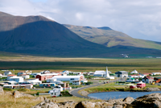
Located just over 20 km north of Blönduós, this is a thriving fishing town in an area of great geological interest with many unique rock formations. There has been a trading post on this site since shortly after the settlement of Iceland over 1000 years ago.
Local services are excellent, meeting commercial and domestic daily needs.
Fisheries companies and support industries have traditionally dominated the employment market in the town. Several innovative companies are located here along with a marine biology research institute. More recently, cultural and tourist services have played an increasingly important role.

Rural areas
Status: Sparsely populated rural districts
Population:
Main fields of employment: Farming
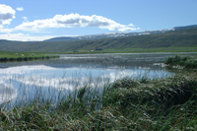
The County of Austur Húnavatnssýsla includes areas of rich agricultural land. Traditional farming methods combined with modern technology are applied in dairy farming and in rearing livestock (sheep, beef and horses). Many large farms are located in this area.
The lowland areas along the coast are productive pastureland while the heaths and hills provide fine summer grazing.
Tourism is an increasing source of income in more accessible districts. The area has a rich heritage and some of the country's best salmon rivers flow through the area. Large colonies of seabirds nest along the coast where seals are a common sight.
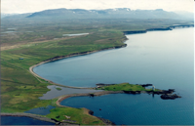
There are country schools and a hotel where a number of more populous valleys meet.
Natural hot water is pumped from boreholes in the area and used for heating.
Further inland, on the edge of the highlands, the force of the River Blanda has been harnessed by a large hydroelectric power plant.
The county reaches to the centre of the highlands and includes a geothermal site among the glaciers called Hveravellir, one of Iceland's most cherished natural attractions.

Communications
The national highway runs through the County of Austur Húnavatnssýsla and through the main town in the area, Blönduós. The speed limit on normal roads outside urban areas is 90 kph.
Road links within Iceland
Reykjavík (capital city, all services): 243 km
Akureyri (main town in N. Iceland): 145 km
Sauðárkrókur (nearest domestic airport): 47 km
Airports
Blönduós: Airfield for private and emergency flights
Sauðárkrókur: Scheduled flights to Reykjavík
Sea
Blönduós: Safe harbour
Skagaströnd: Active fishing port - good facilities

Resources
The region has plentiful environmentally-friendly supplies of electricity, and hot and cold water. The workforce is relatively young and well educated.

Electricity
Austur Húnavatnssýsla County has good access to reliable electricity supplies.
Blanda Station - 150 MW of hydroelectric power
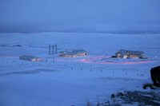
Landsvirkjun, the national power company, operates Blanda Station, a hydroelectric installation on the edge of the highlands. The power plant's energy resources are entirely renewable and environmentally friendly. All of the facilities and man-made structures are exemplary, and the operation complies with the requirements of the relevant ISO standards for quality management and environmental controls.
The power plant has a capacity of 150 MW and taps the potential of the River Blanda, one of Iceland's longest glacial rivers. The power plant's operational reliability stands at over 99%, and the plant is connected to the country's main electrical grid.
Smaller power units
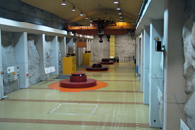
The Laxárvatn power plant is a smaller unit with a generating capacity of 0.5 MW which also exploits hydroelectric potential in the area.
Available by negotiation
Substantial and reliable electricity supplies can be provided for industrial and commercial units of all sizes. Energy supplies are subject to contractual arrangements and prices vary somewhat depending on the quantity of electricity required.

Power connections
Austur Húnavatnssýsla County has good access to the electricity supply system.
Power line access points
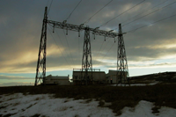
Electricity distribution in Iceland is mostly controlled by Landsnet, a subsidiary of national power company. Suppliers and major industrial users connect directly to Landsnet's national grid, which provides supplies of 66kV or more. Every major power plant in Iceland is connected to the national grid.
A network of energy supply companies delivers energy to consumers over Landsnet's delivery system, which is made up of 132 kV and 66 kV high-tension power lines.
Connections in and around Blönduós are good due to the town's proximity to a 132 kV grid line. A Landsnet 132 kV switching station located nearby benefits from two separate supplies from different generating stations.
As an example of the system's flexibility, it would be quite feasible to provide a new, dedicated power supply for a data centre near Blönduós.
Skagaströnd and other places on the Skagi peninsula are connected through a single 33/11 kV line. The stability of the supply will be improved in the future, particularly for a new installation that required a high-quality connection.

Water
A good supply of cold water suitable for consumption or cooling already exists in Blönduós. Current boreholes have a capacity of 45 l/s whereas present requirements are less than 20 l/s.
The water utility in Skagaströnd can supply 35 l/s of potable cold water. There is potential for a substantially greater supply of water for cooling purposes.
An industrial installation that requires large quantities of cooling water could be located on the banks of the River Blanda, one of Iceland's most powerful glacial rivers. Water from this source would possibly require some degree of treatment before use.
The availability of cooling water in industrial quantities should not be problematic in any location in the county.

Heating
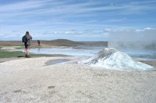
The County of Austur Húnavatnssýsla enjoys rich sources of geothermal heat. One source is located a few kilometres from the town of Blönduós. Hot water is piped from boreholes on the site to heat buildings in the town and surrounding rural areas.
Further research and drilling could undoubtedly yield large quantities of hot water for industrial applications and space heating. The supply network could then be extended along the coast to Skagaströnd and smaller rural communities.
Large-scale horticultural applications are possible. Extensive sites are available.

Workforce
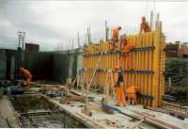
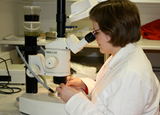
The general level of education in the County of Austur Húnavatnssýsla is very high. Over 20% of the workforce have a university degree.
Vocational training centres ensure that the range of available skills can meet the needs of industry and residents.
Unemployment currently remains low, although this is largely due to a decrease in the local population.
Demographics
Total population of region: 7400
Average age: 35
Size of workforce: 4000 (approx. 55% of population)
Industrial installations require a large workforce. Recent experience in Iceland has shown that even in times of very low unemployment, industries based in seemingly remote areas have had no problems finding personnel. In cases where the local population has been too small to provide the necessary manpower, or when the installation is located some distance from a populated area, workers have been attracted from further afield. A large number of families have relocated to be close to their workplaces, even from overseas. Road and air connections are good enough to bring most of Europe within 4-6 hours travelling time.

Industrial areas
The County of Austur Húnavatnssýsla has a large area of land designated for industrial or commercial use. Sites are available for small businesses, light industry, technology companies and other concerns. Large-scale heavy industrial installations can also be accommodated. Large areas of land are available for development and companies looking for extensive sites at attractive prices are invited to contact us. Utility services are scalable for all types of activities, and special high-tension electrical power supplies can be made available for the heaviest applications. There are ample supplies of clean water. Hot water can be provided for space heating. High-capacity, high-speed data connections already exist and are indeed being further upgraded at this time. Please contact one of our international representatives for further details about the facilities we can offer. | 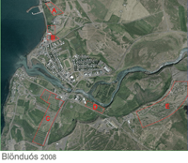
 | 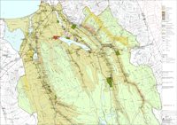
 | 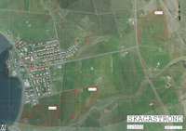

Community
The County of Austur Húnavatnssýsla has worked hard towards creating a family-oriented environment with a full range of services for the community.
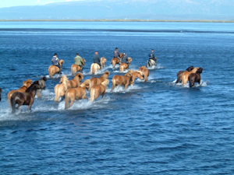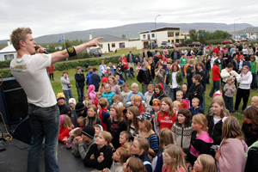

Education
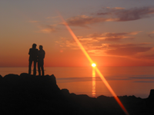
The level of education in Iceland is among the best in the world. The County of Austur Húnavatnssýsla and the surrounding areas together provide a complete range of educational establishments, from nursery schools to universities and vocational training centres.
School is compulsory for all children in Iceland aged 6 to 15 years. Many young children attend nursery schools run by local authorities for their residents. A large proportion of young people continue their studies at a further education college, usually until they are around 19 years of age. University is then the next step.
There are nursery schools and compulsory schools in main population centres and further education colleges in nearby towns where student accommodation can be easily arranged.
Two universities in the region offer business-related degree courses and specialised courses in rural tourism, equine science and aquaculture.
Over 20% of residents in the region hold a university degree, while many others have specialist training and experience in a wide range of trades and vocations. The workforce is highly skilled yet extremely flexible and prepared to tackle new fields at any time.

Services
We make every effort to maintain a complete range of services for residents, agriculture and industry.
- Local hospitals and health centres
- Efficient utilities
- Range of food and retail outlets
- Vehicle and building maintenance
- Police
- Fire and emergency services
- Local government offices
- Compulsory schools (6-15 yrs.) and nursery schools in towns and rural areas
- Music schools in several locations in the county
- Sports and recreation centres
- Swimming pools
- Hotels and restaurants
- Libraries and museums
- Cultural centres
- Tourist information

Health
As in other Nordic countries, Iceland has a comprehensive welfare state system that includes a modern public health service.
Health centres and local hospitals provide a range of basic services. Serious cases are transferred to main population centres where specialists and consultants are also available. Local doctors, nurses and health advisors are accessible at all times as are pharmacy facilities.
Ambulance services operate throughout the region. In extreme cases, patients are transferred by helicopter or aeroplane.
Iceland complies with the directives and recommendations of international health organisations and wide-ranging immunisation programs have been implemented.

Accomodation
House prices in the County of Austur Húnavatnssýsla are very advantageous compared with more densely populated areas of Iceland. A wide range of houses and apartments are available, both for purchase and for leasing. Local authorities also provide a range of building plots for those who wish to build their own accommodation.
Local estate agents can provide information about property on the market. They will also assist in sales or leasing procedures.

Recreation
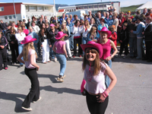
The County of Austur Húnavatnssýsla recognises the importance of providing high-quality, accessible recreation and sports facilities.
There are organised activities for all age groups. Facilities are open to the public, including local residents, visitors and tourists.
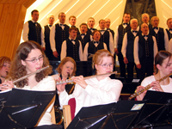
- Football, handball and basketball are popular team sports
- Organised training takes place under national schemes
- Swimming pools in almost every community
- All Icelandic children learn to swim
- Golf is also growing in popularity during the summer months
- Riding is a popular pursuit
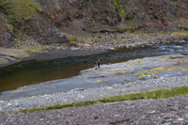
- Vast area of open land for hikers
- Accessible mountains, valleys, moors, glaciers, coastal plain
- Fishing - salmon and trout - sea angling
- Activities of ranger scouts and mountain rescue teams overlap in many areas
- Music schools offer teaching on a range of instruments
- Choirs and drama groups welcome new members, young and old
- Libraries and museums
- Festivals on many occasions

Costs and concessions
Prospective investors in new commercial or industrial developments can negotiate with the County of Austur Húnavatnssýsla (the local authority) regarding prices and facilities. The price of land is very favourable and related levies are low.
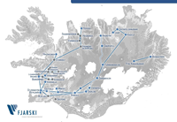
Concessions
Large installations may qualify for extra concessions while development is in progress. These concessions include reductions or postponement of charges for land, utilities, road building, property taxes and other expenses.
Competitive electricity prices
Electricity prices are very competitive compared with other Western countries. You should also bear in mind that all our electricity is generated using sustainable, environmentally-friendly resources. Large-scale consumers of electricity negotiate directly with Landsvirkjun, the national power company.
Information Centre
The Association of Local Authorities in North-West Iceland can assist in providing information and advice concerning every aspect of planning, implementing and installing new industrial, commercial or technological concerns in the region. We can help put you in contact with the correct departments and the right people, and we deal with each enquiry on an individual basis, promptly and confidentially.
Our international representatives will answer your questions and help set you on the right track. See our contact page to find out how to get in touch.

Climate
Although Iceland is further north than much of Canada and Russia, the climate is considerably milder than you might expect.
Warming effect of the Gulf Stream
The relatively warm Gulf Stream flows around the shores of Iceland, keeping harbours free of sea ice all year round. Ice floes that break off the Greenland coast occasionally drift cross the Denmark Strait during the summer months, but there is always plenty of warning prior to any danger.
The average winter temperature is just below 0°C, while the mean temperature in the summer months is just over 11°C.
Summertime is mild with a fair amount of rain. There is continuos daylight for almost three months in May, June and July.
Winter snow cover is variable, but main roads are rarely closed for long periods. Vehicles are well equipped to cope with icy surfaces and delays due to the weather are limited to a very few days each year on average. Daylight in midwinter is limited to about 5 hours.
Storms can occasionally make life uncomfortable, but weather forecasts are becoming more and more accurate – preparations can be made in advance and journeys can be undertaken sooner or later that originally planned.

